Write a Python Program for the Vacuum Cleaner Problem
AIM:
To write a Python program to simulate the Vacuum Cleaner problem using Artificial Intelligence.

Objective
To clean all dirty rooms by allowing the vacuum cleaner agent to sense the environment and perform the appropriate action.

Algorithm
- Start.
- Initialize the two rooms (A and B) as Clean or Dirty.
- Place the vacuum cleaner in one of the rooms.
- Check the current room.
- If the room is Dirty, clean it.
- Otherwise, move to the next room.
- Repeat until all rooms are clean.
- Stop.
Flowchart :
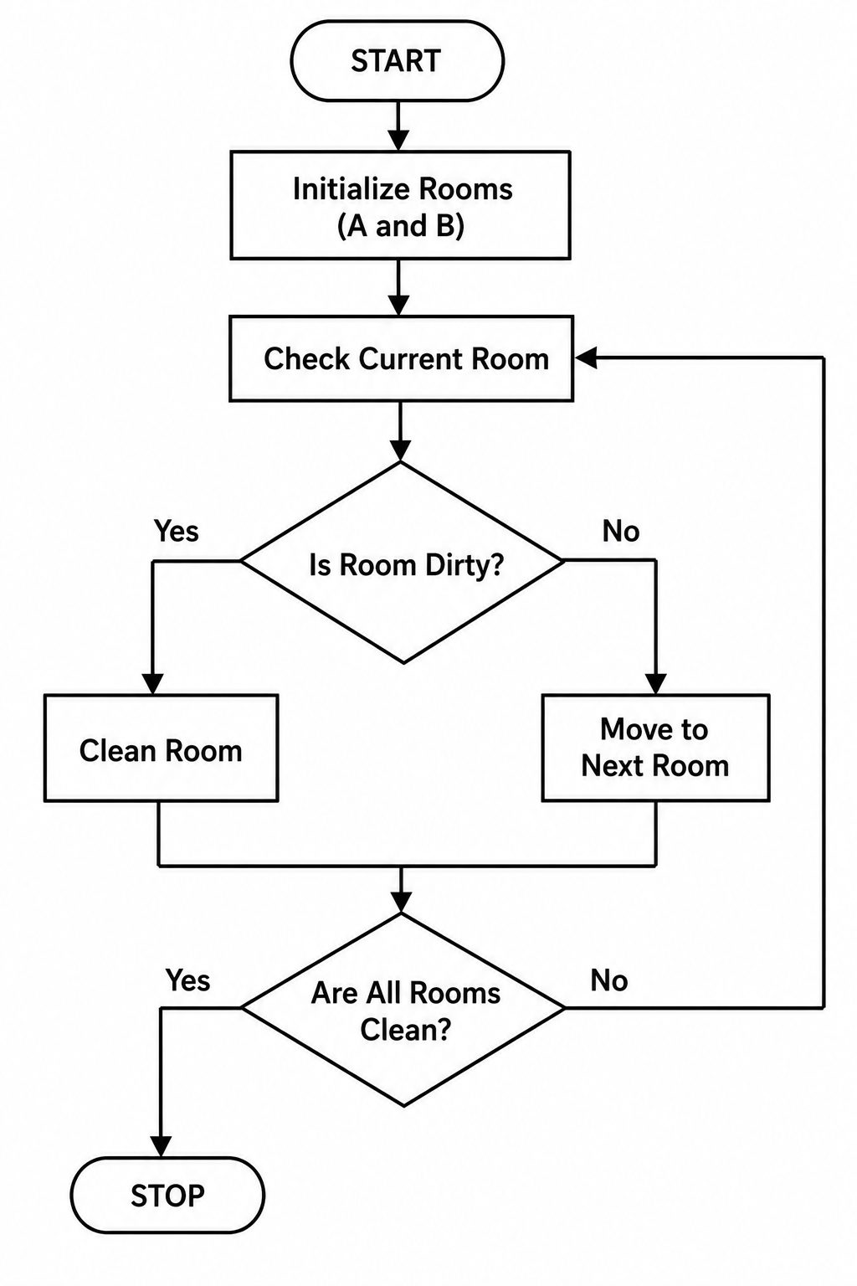
Code:
rooms = {"A": "Dirty", "B": "Dirty"}

for room in rooms:
print("Room", room, "is", rooms[room])

if rooms[room] == "Dirty":
print("Cleaning Room", room)
rooms[room] = "Clean"

print("\nFinal Status:")
for room in rooms:
print("Room", room, "is", rooms[room])

OUTPUT:
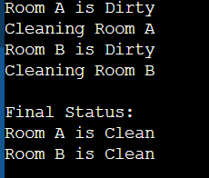

RESULT:
The Python program successfully cleaned all the dirty rooms using the Vacuum Cleaner agent.
CONCLUSION:
The Vacuum Cleaner problem was successfully implemented in Python. The agent sensed the environment, cleaned dirty rooms, and ensured that all rooms were clean, demonstrating the concept of a simple reflex agent in Artificial Intelligence.

